**RESTAURANT WEBSITE**

END TERM REPORT

BY

**ASHIRVAD DUBE, MO SAHIL, ARYAN SINGH**

(Section: KOC05)

(Roll numbers: A05, A07, A18 )



Department of Intelligent Systems

School of Computer Science Engineering

Lovely Professional University, Jalandhar

December-2022

**STUDENT DECLARATION**

This is to declare that this report has been written by us. No part of the report is copied from other sources. All information included from other source have been duly acknowledged. We aver that if any part of the report is found to be copied. We shall take full responsibility for it.

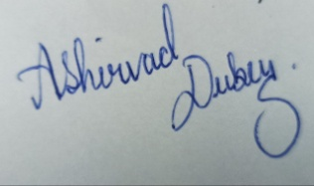

Ashirwad Dubey

Roll No:A05

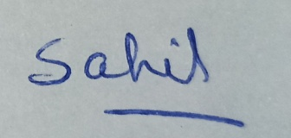

Mo Sahil

Roll No:A07

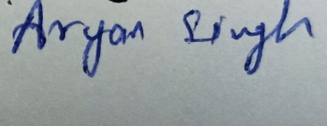

Aryan Singh

Roll No:A18

Date : 12/12/2022

TABLE OF CONTENTS

Title Page No

**1 INTRODUCTION 1**

**2 OBJECTIVES OF THE PROJECT 1**

**3 FEATURES OF THE PROJECT 1**

**4**  **SCREENSHORTS 2-6**

**INTRODUCTION**

A place where you can buy and eat a meal online and offline both .It fulfils the needs for connection and shaped social relation. A famous restaurant is known for great tasting food is a vital feature of a good restaurant.

**OBJECTIVE OF PROJECT**

- Increase sales and profit

- Increase the exposure of the Restaurant

- Keep the amazing offers inexpensive and low cost

- A clear call to action

- Online ordering

**FEATURES OF THE PROJECT**

- Focus on quality over quantity

- Simplicity

- Separate menu are available

- Social networking

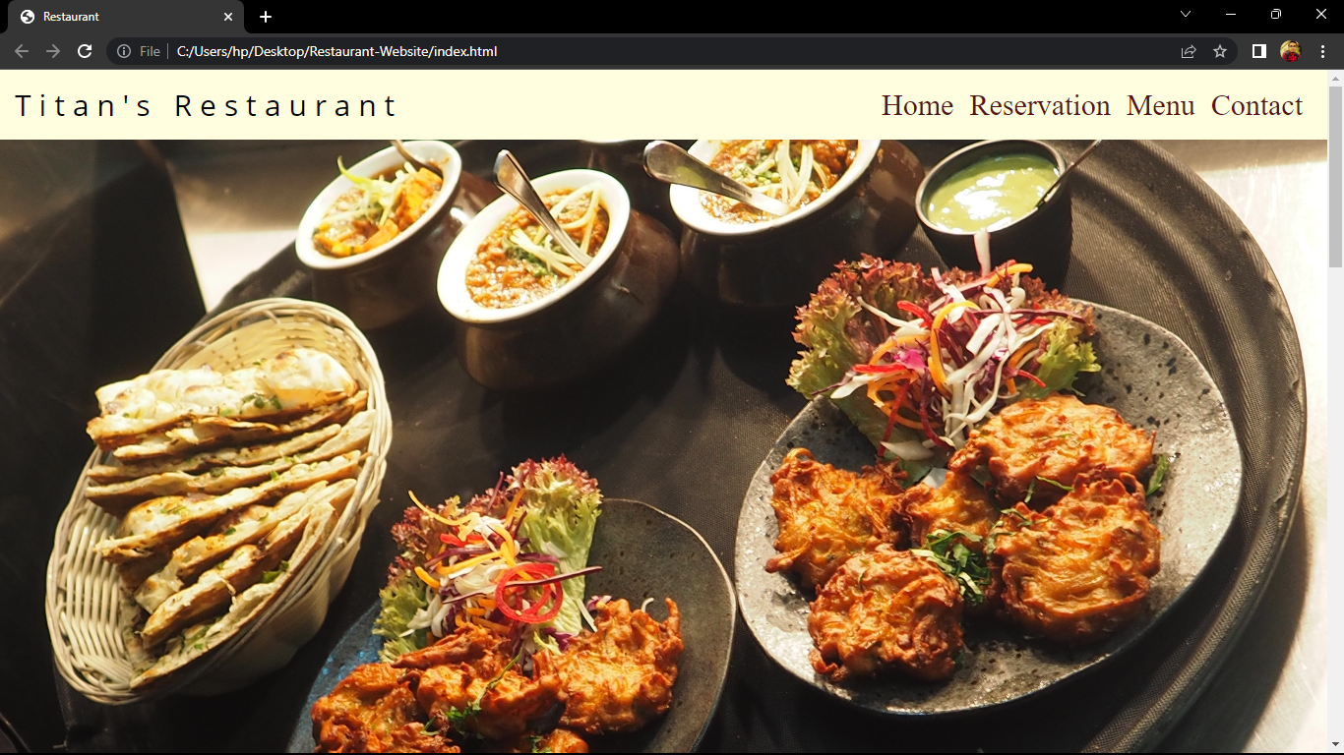

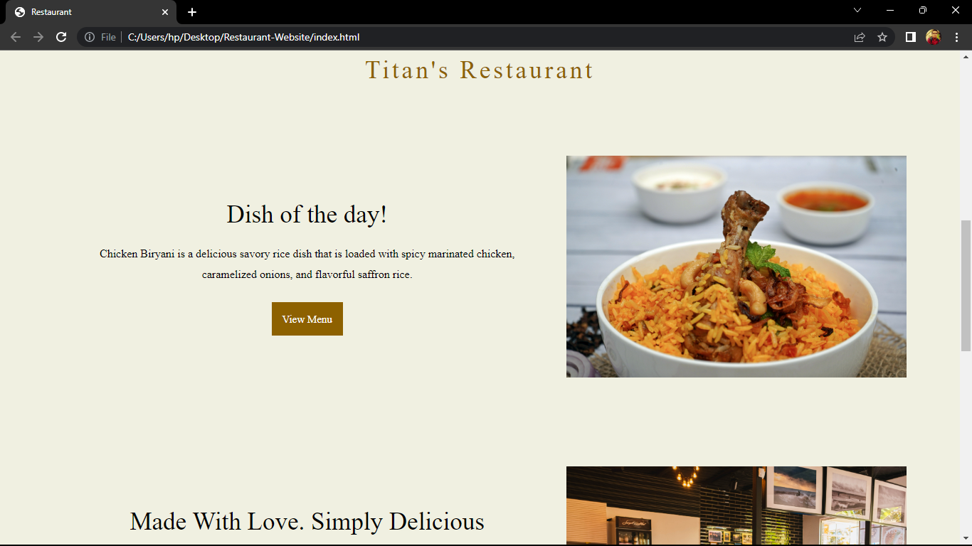

Homepage

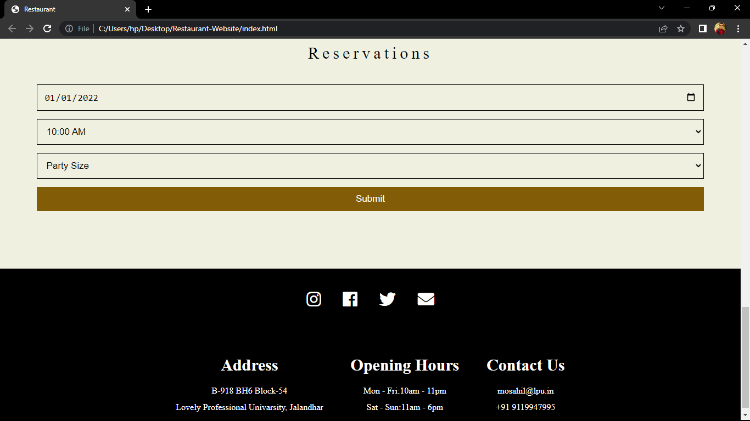

Reservations

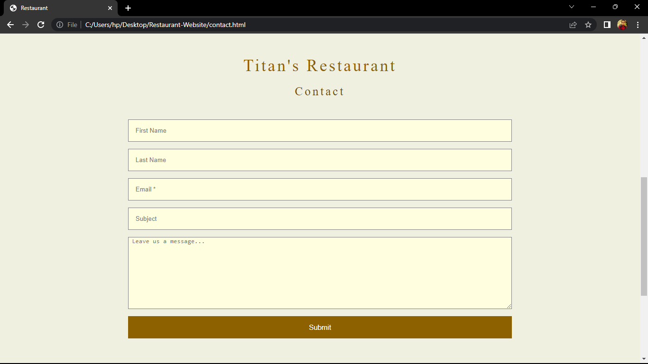

Contact Us Page

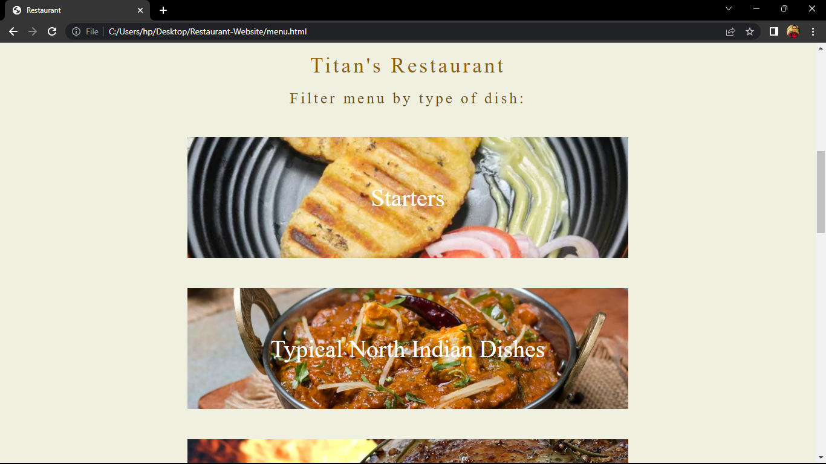

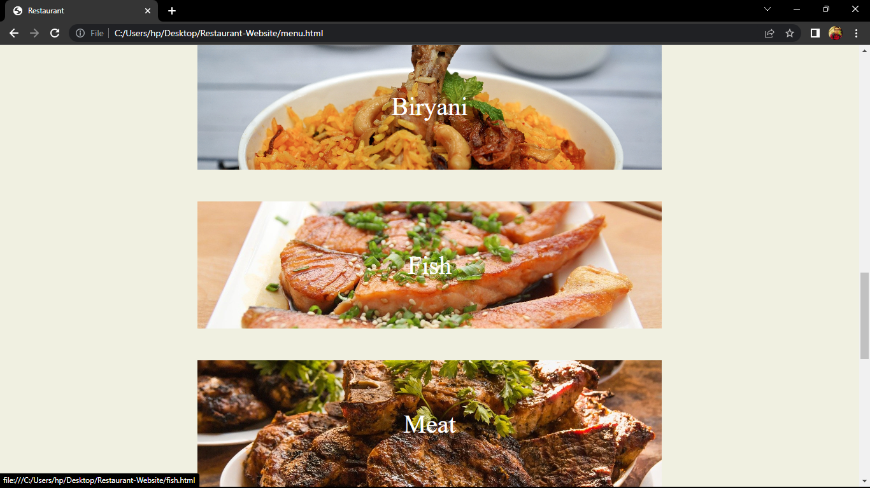

Menu Page

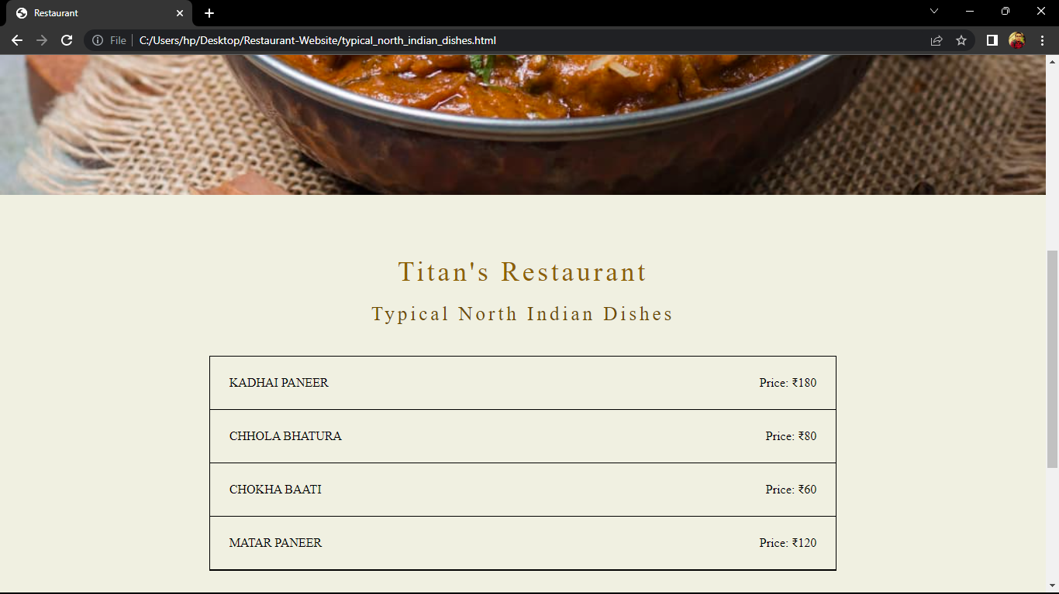

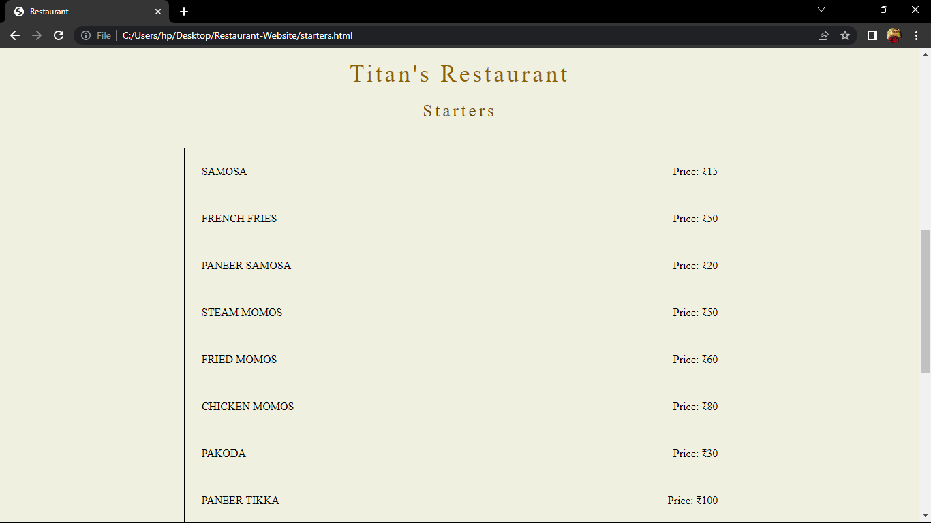

Sub Pages

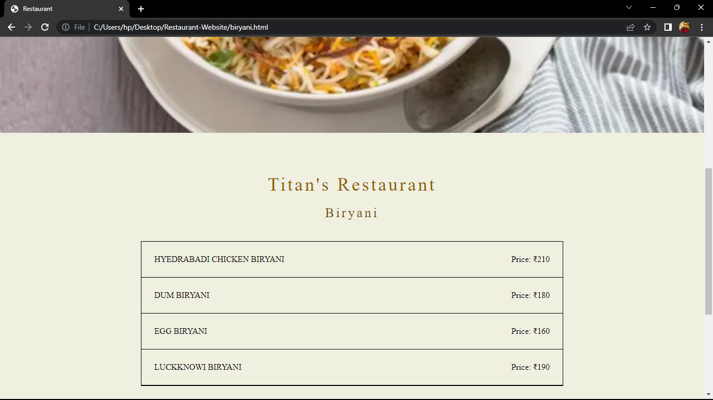

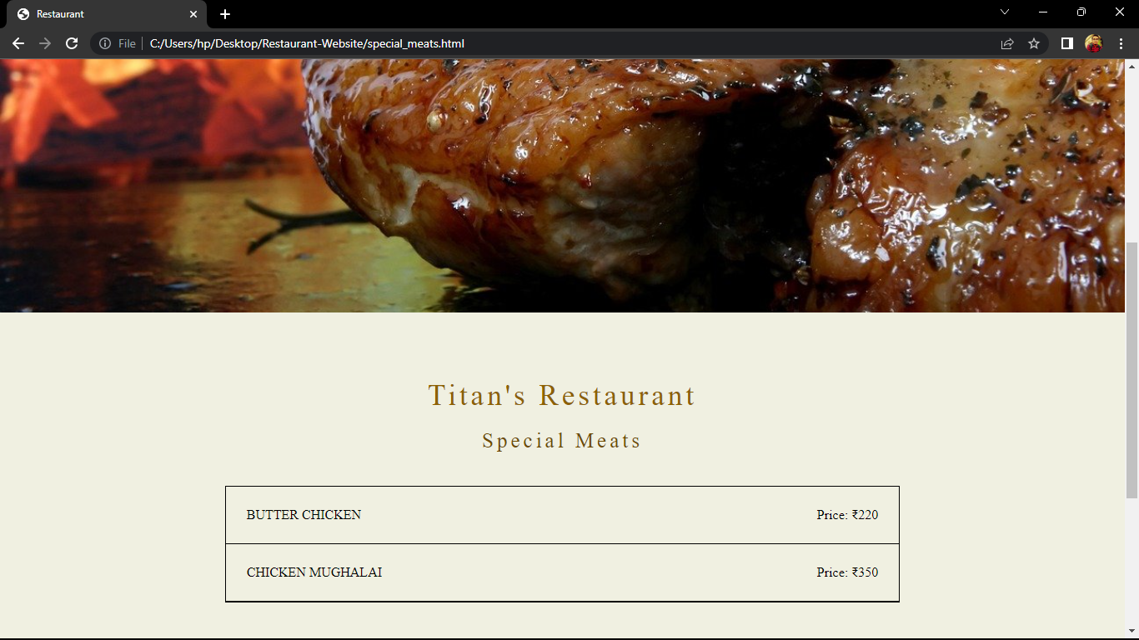

Sub Pages

BONAFIDE CERTIFICATE

Certified that this project report “Restaurant website” is the bonafide work of ARYAN SINGH, MO SAHIL, ASHIRVAD DUBEY who carried out the project work under my supervision.

Sushil Lekhi

CSE